## Pololu Maestros Servo Controller

Pololu Maestro servo controller is a USB servo controller. It contains a USB slave port to direct connect to PC, TTL serial (TX/RX) for use with embedded system, and self-contained script for servo control.

Pololu Maestro controller provides USB dual port, USB chained, and UART mode.

Manual: <http://www.pololu.com/docs/pdf/0J40/maestro.pdf>

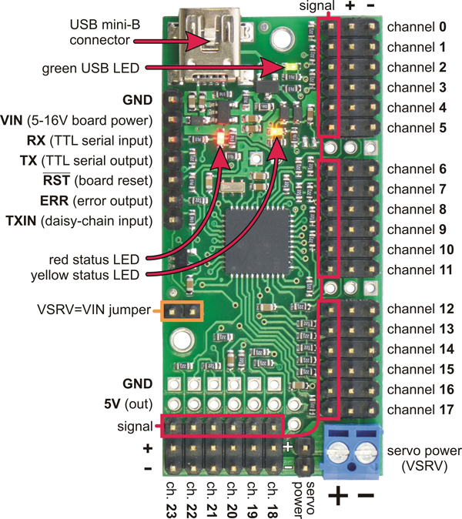

Figure : [Mini Maestro 24-channel USB servo controller top view](http://www.pololu.com/picture/view/0J2341)

There are three serial modes of Pololu Maestro: USB dual port, USB chained, and UART. By using the ‘UART, detect baud rate’ mode, the command for the Pololu Maestro can be received via TTL RxD.

## Arduino Mega 2560

The Arduino Mega 2560 is a microcontroller board. It has 15 PWM outputs I/O pins, 16 analog inputs, 4 UARTs, and a USB connection.

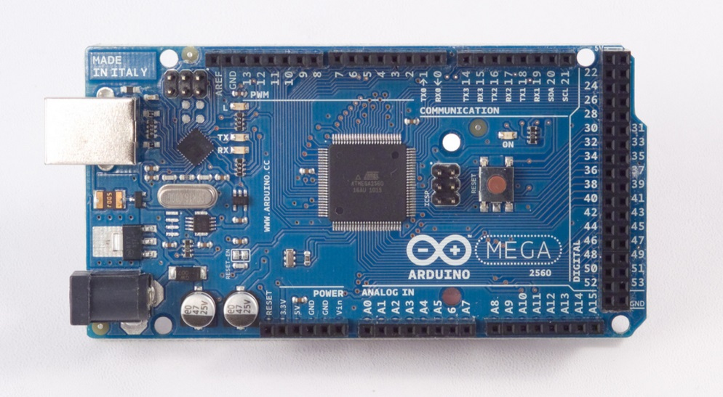

Figure : Arduino Mega 2560 Front